1. Go back to your N2P116date.php file, and, instead of displaying only the number of days in the current month, add a few lines that say:

Yesterday it was ______________.

The previous month is ______________.

There are ___________ days left in this month.

There are ___________ months left in the current year.

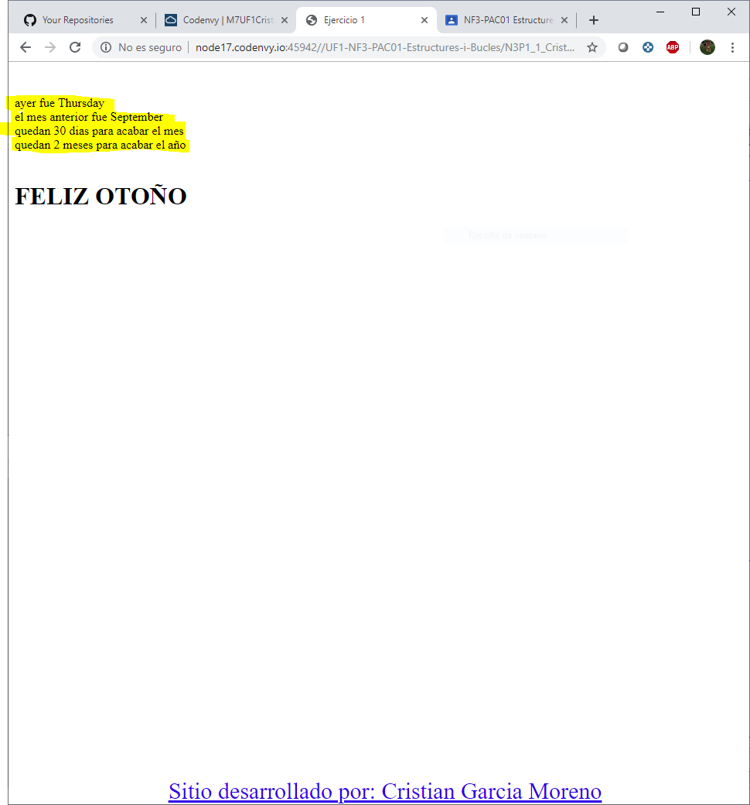

1. On your movie web site, write a file that displays the following line at the

bottom center of every page of your site, with a link to your e-mail address.

Site developed by: ENTER YOUR NAME HERE.

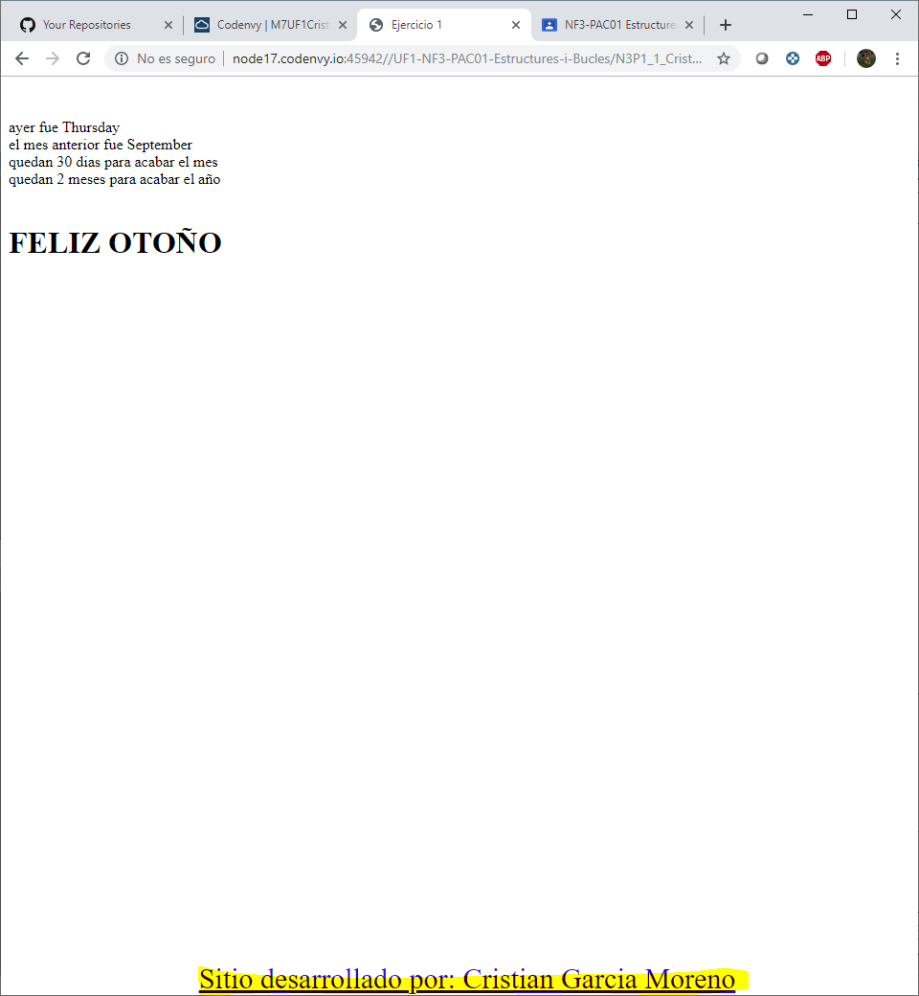

1. Write a program that displays a different message based on the month. For

example, have the site display “Good Summer!” if it is accessed in a summer

day, or “Good Winter” in a winter day.

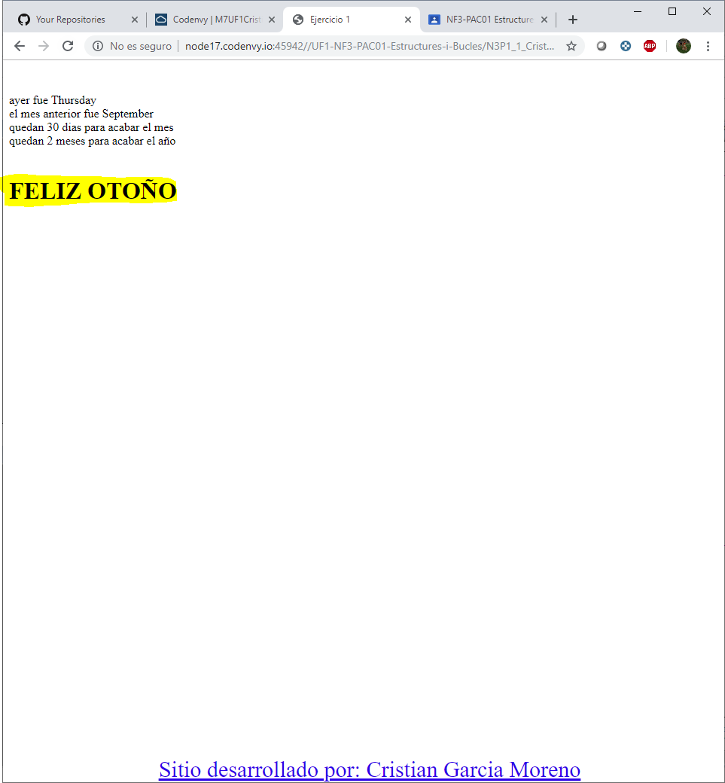

1. Write a program that formats a block of text (to be input by the user) based

on preferences chosen by the user. Give your user options for color of text, font

choice, and size. Display the output on a new page. Use inline CSS.

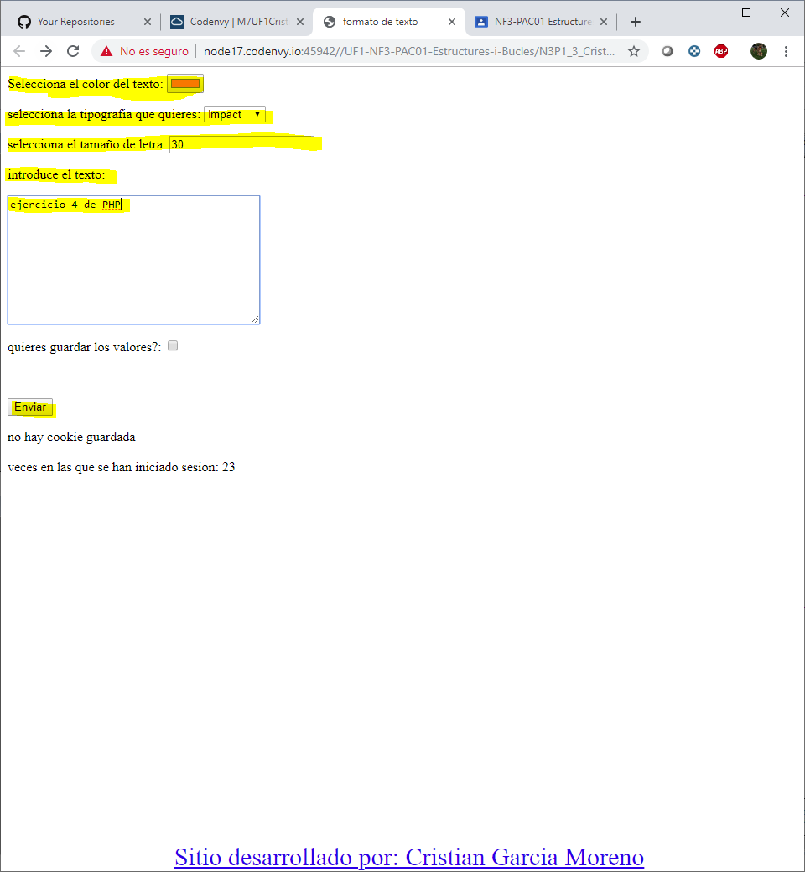

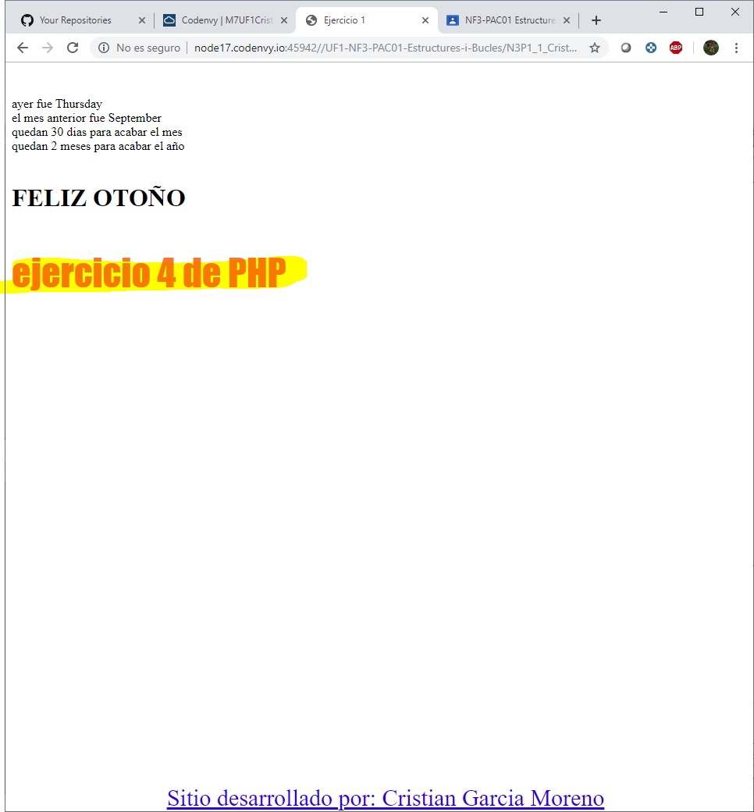

1. In the program you created in step 4, allow your users the option of saving

the information for the next time they visit. If they choose “yes” save the

information in a cookie.

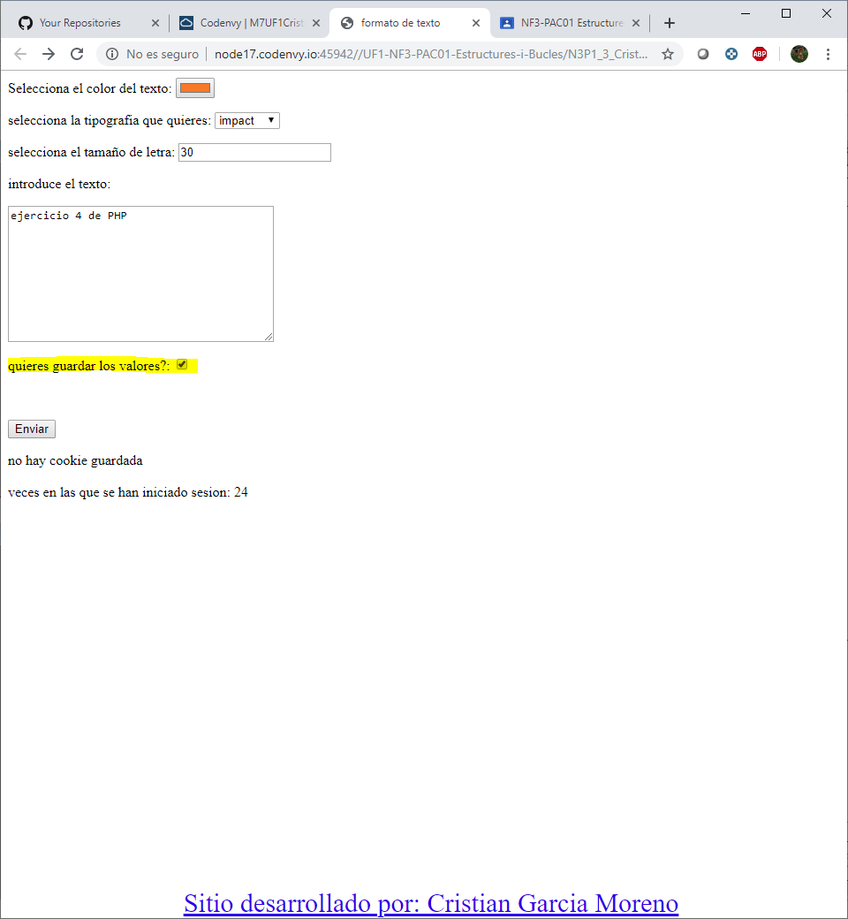

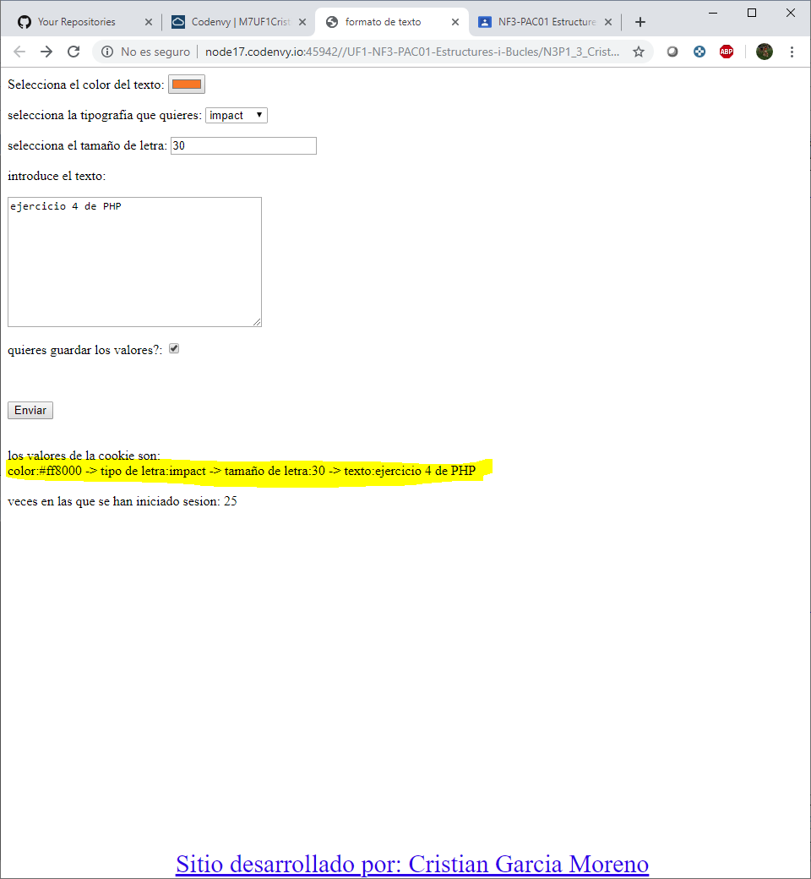

1. Using sessions, write a program that keeps track of how many times a visitor

has loaded the page.

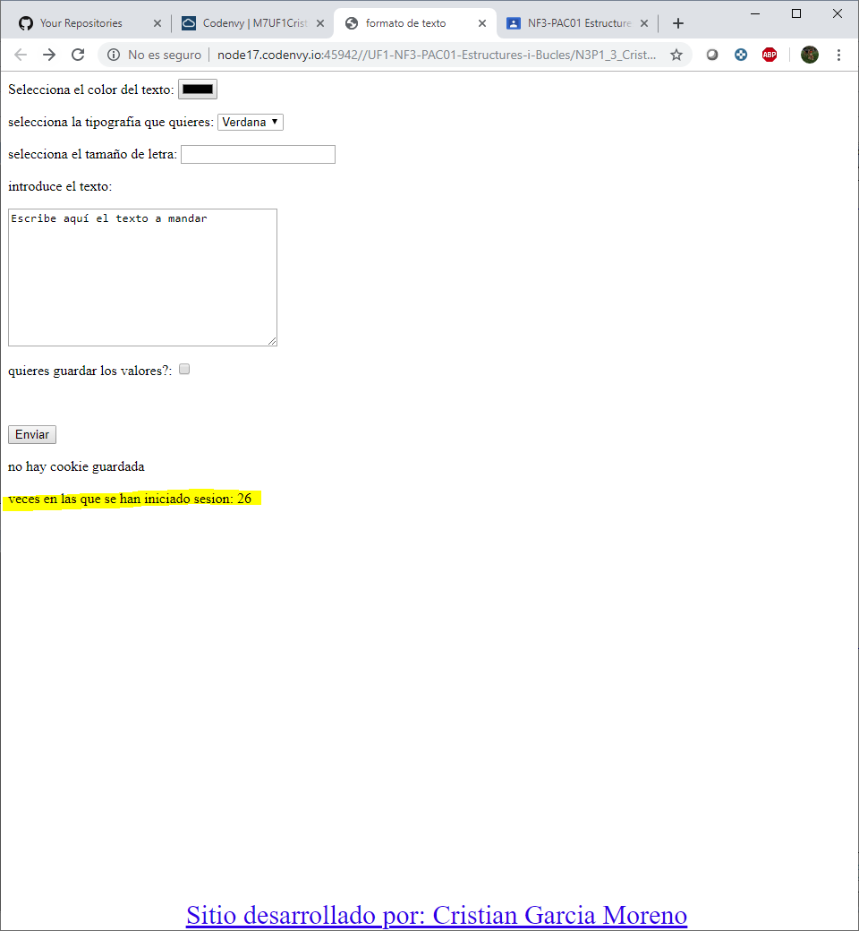

1. Create the file N3P117comments.php:

* Create a list of the 10 most important concepts about what you’ve

learned in this document.

* Qualifies the document (0-10), and the teacher's explanation (0-10).
* As a student, put a mark to yourself.
* Explain an improvement.

